**CS342 – Operating Systems Lab**

**Assignment-5**

Tarusi Mittal 1901CS65

**1. The main thread creates ten threads. Then it waits for the threads to terminate, printing the status returned by each thread. The last thread was cancelled which is recorded in the output. Write a C program for this behaviour.**

Ans:

Compilation: gcc -o q1 q1.c -lm -pthread -fopenmp

Syntax: ./q1

Examples of Execution:

Input: gcc -o q1 q1.c -lm -pthread -fopenmp

./q1

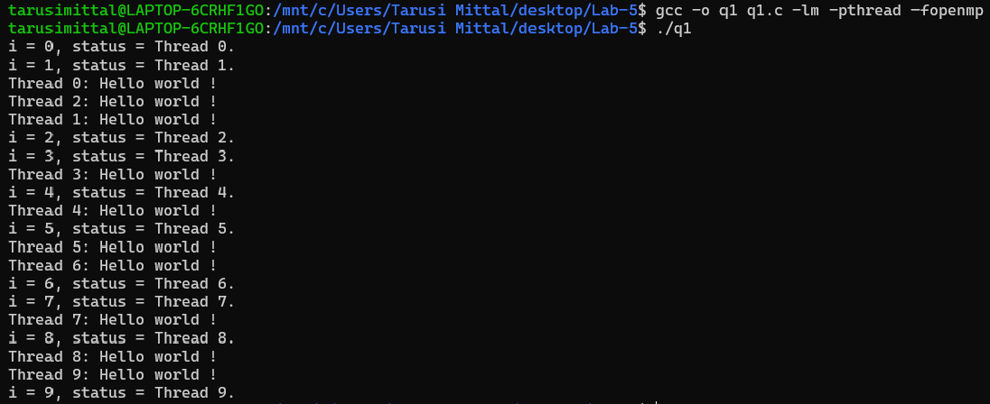

**2. Write a C program using two threads to write a text file where first thread writes all the lines except prime numbered lines and second thread writes all the prime numbered lines. The third thread should parallelly count the number of characters being written in each line of the file.**

Compilation: gcc -o q2 q2.c -lm -pthread -fopenmp

Syntax: ./q2 file1 file2

Examples of Execution:

Input: gcc -o q2 q2.c -lm -pthread -fopenmp

./q2 file1.txt file2.txt

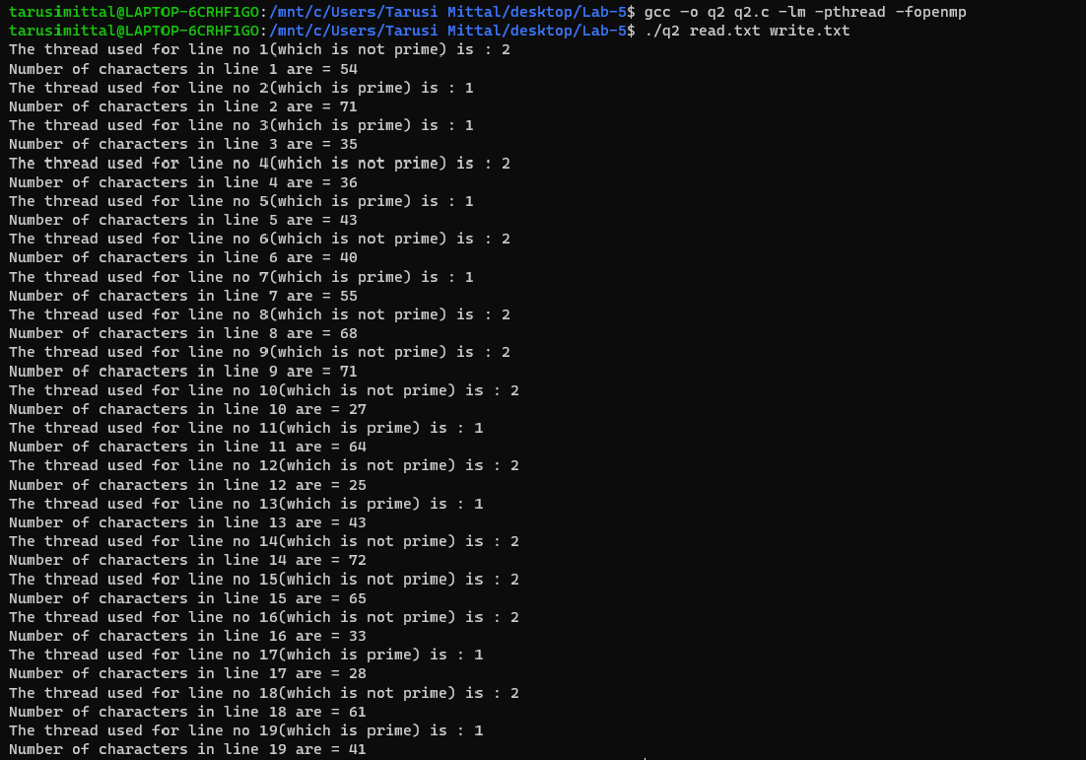

**3.** **There are “M” vending machines linked to single petrol tanker with capacity of “L” litres. “ni, where 0<i<=M” number of customers are coming to each machine in “M” different queues to take some petrol in parallel manner. The vending machine should dispense only if the required amount of petrol is available in the tanker. And after dispensing to each customer the amount of petrol present in the tanker should be updated. Write a C program using thread for the petrol dispensing system.**

Ans:

Compilation: gcc -o q3 q3.c -lm -pthread -fopenmp

Syntax: ./q3

Input:

**NOTE**: Because of the nature of the input, we are not taking the input from the command line instead we are taking the input from an input file which can simply be edited in notepad or we can use the cat command to read the file on the terminal also.

M -> No of vending machines

Capacity -> the Total litres of petrol capacity in the tank

N1 -> No of customers coming to the first machine

I1 ,I2 , I3 ………….IN1  -> Amount of petrol the Ith person wants to fill

N2 ->

I1 ,I2 , I3 ………….IN2

.

.

.

Nm

I1 ,I2 , I3 ………….INm

Examples of Execution:

Example1

**(input file used in example1.txt)**

Input: gcc -o q3 q3.c -lm -pthread -fopenmp

./q3

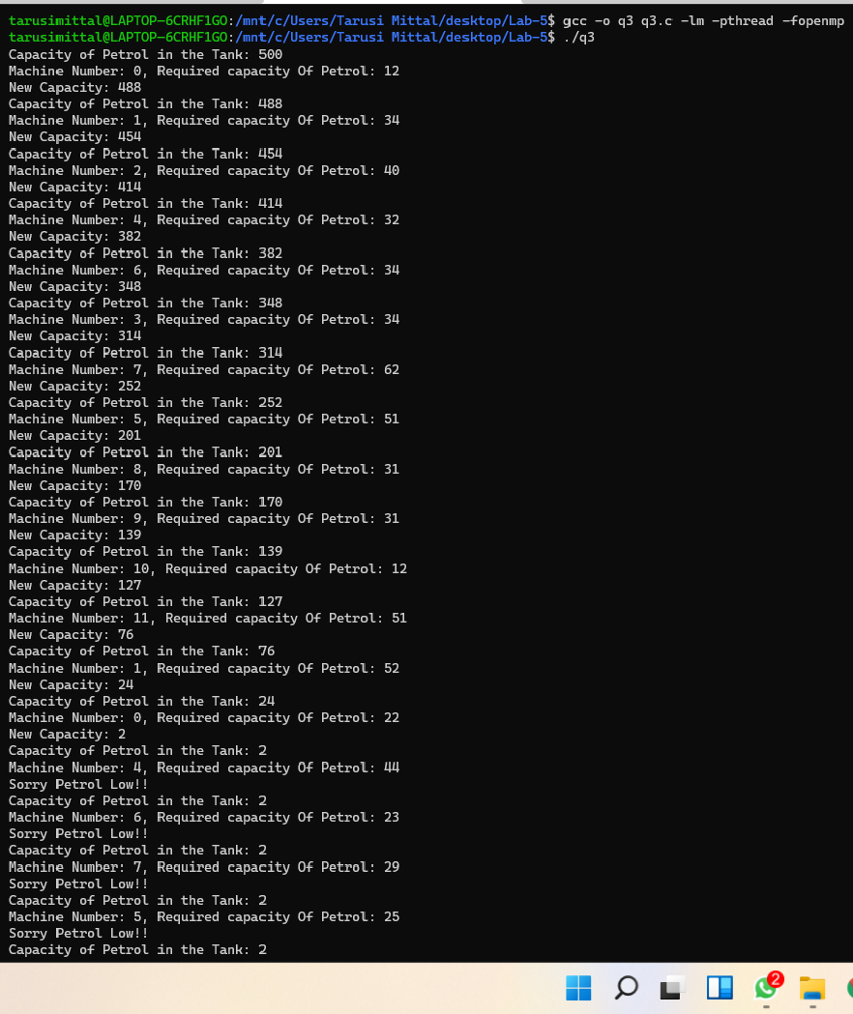

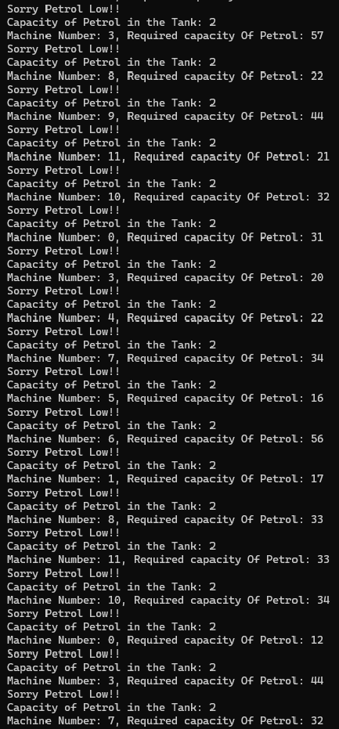 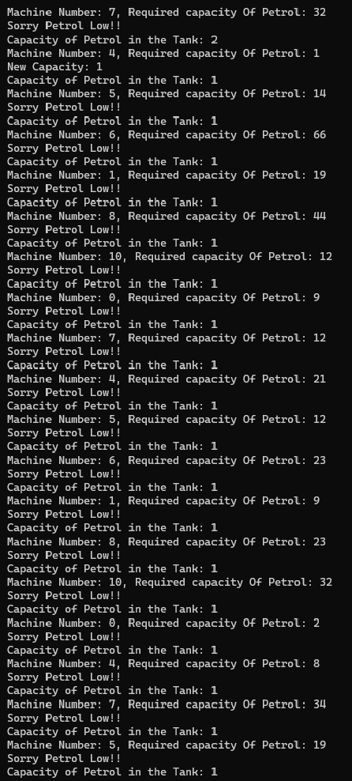

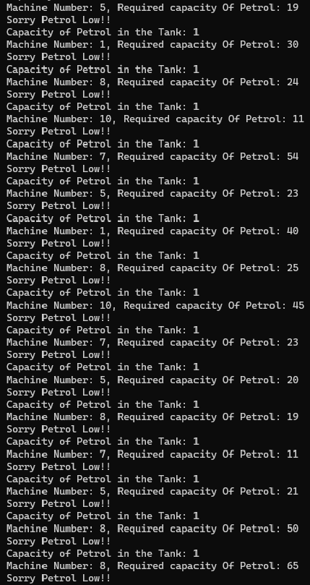

Example2

**(input file used in example2.txt)**

Input: gcc -o q3 q3.c -lm -pthread -fopenmp

./q3

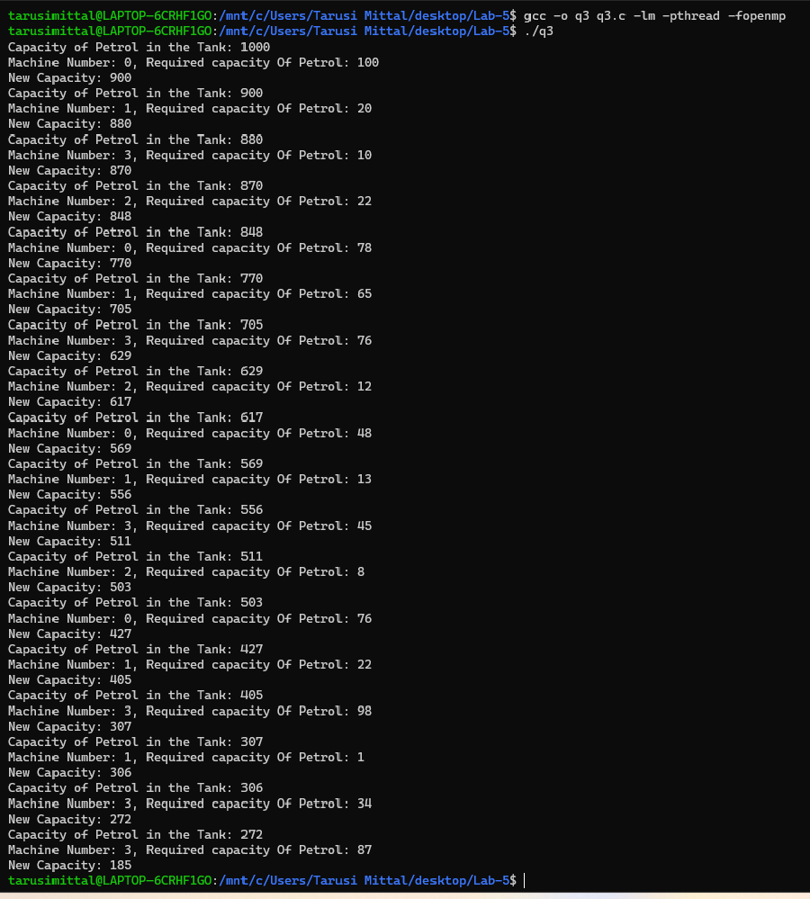

END